MATLAB Syntax
Writing code in the MATLAB environment is quite simple. We do not need to include any libraries/header files, we can directly start writing commands in the command window of the Editor. Usually, we write small and easily executable programs in the Command Window and larger programs with multiple lines and functions in the Editor.
Now, we will see the syntax of a MATLAB program. Let us begin with the very basic code to display ‘Hello World’ as the output in the command window:
Example:
% A MATLAB program illustrate
% disp function
disp("Hello World")
Here, disp() is a function used to display the desired value as the output.
Output:
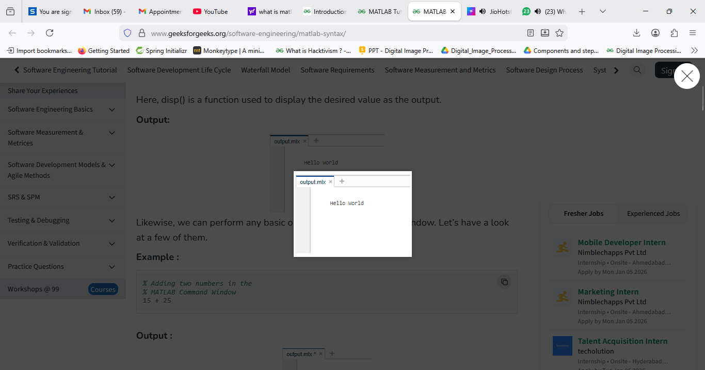
Likewise, we can perform any basic operation in the command window. Let’s have a look at a few of them.
Example :
% Adding two numbers in the
% MATLAB Command Window
15 + 25
Output :
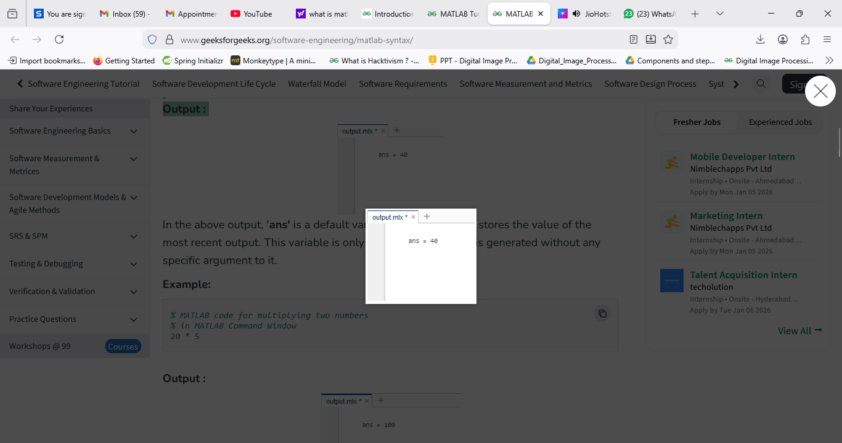
In the above output, 'ans' is a default variable in MATLAB that stores the value of the most recent output. This variable is only created when output is generated without any specific argument to it.
Example:
% MATLAB code for multiplying two numbers
% in MATLAB Command Window
20 * 5
Output :
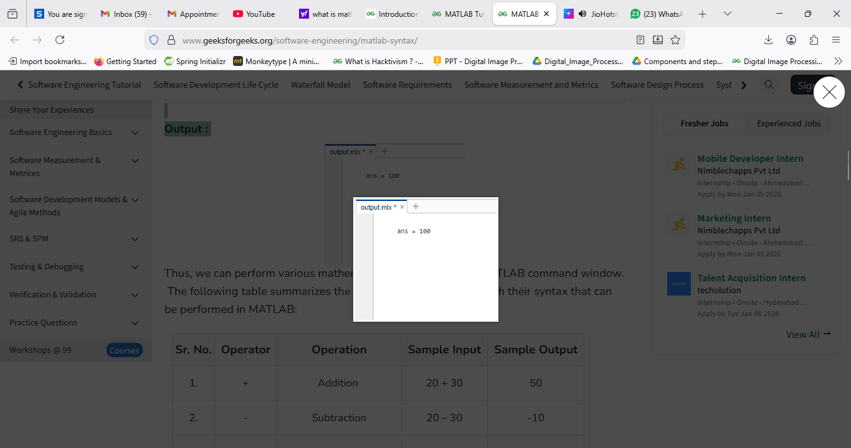
Thus, we can perform various mathematical operations in the MATLAB command window. The following table summarizes the various operations along with their syntax that can be performed in MATLAB:

Sr. No. | Operator | Operation | Sample Input | Sample Output
1. | + | Addition | 20 + 30 | 50
2. | - | Subtraction | 20 – 30 | -10
3. | * | Multiplication | 20 × 30 | 600
4. | ^ | Exponentiation | 2 ^ 3 | 8
5. | \ | Left-division operator. | 10\5 | 0.5000
6. | / | Right-division operator. | 10/5 | 2

Declaring Variables in MATLAB
Declaring Variables in MATLAB is fairly simple. We just need to write a valid name for the variable followed by an equal sign ('='). The naming of variables is discussed further in this article. In MATLAB, we need not explicitly mention the type of variable while declaring it,

a=7 %declares an integer variable and assigns it the value 7
b=9.81 %declares a float (decimal) variable and assigns it the value 9.81
c = [1,2,3] %declares an array and assigns it the values 1, 2 and 3
d=a = [1,2,3;4,5,6;7,8,9] %declares a 2-D array and assigns it the values 1,2,3,4,5,6,7,8 and9

Naming Variables in MATLAB
The rules for naming a variable in MATLAB are as follows:
- A variable name must begin with a letter which may be followed by letters, digits, or underscores (no other special character allowed).
- MATLAB is case-sensitive which means that upper and lower case letters are considered different. (‘GeeksForGeeks’ and ‘geeksforgeeks’ are considered separate variable names)
- Avoid giving variables the same name as that of existing MATLAB functions.

Examples of valid MATLAB Variable Names
Valid MATLAB Variable Names
Geeks
A_bcd
CoDing2001
First_Val

Examples of valid MATLAB Variable Names
Variable Name | Cause for Invalidity
7Abc | Variable name should always begin with an alphabet
_Geeks | Variable name should always begin with an alphabet
end | Variable names should not be the same as already existing MATLAB functions
Coding!! | Variable names should not have any special characters except underscore

Use of semicolon in MATLAB
Unlike many programming languages, every statement/expression in MATLAB need not necessarily end with a semicolon. However, in MATLAB, a semicolon is used at the end of a statement to restrict the result of the statement from being displayed in the output.
Let us understand this with a few examples:
Example:
% MATLAB code to assign values
% to two variables and display
% their sum (without the use of
% any semicolon)
a=2
b=3
c=a+b
Output:
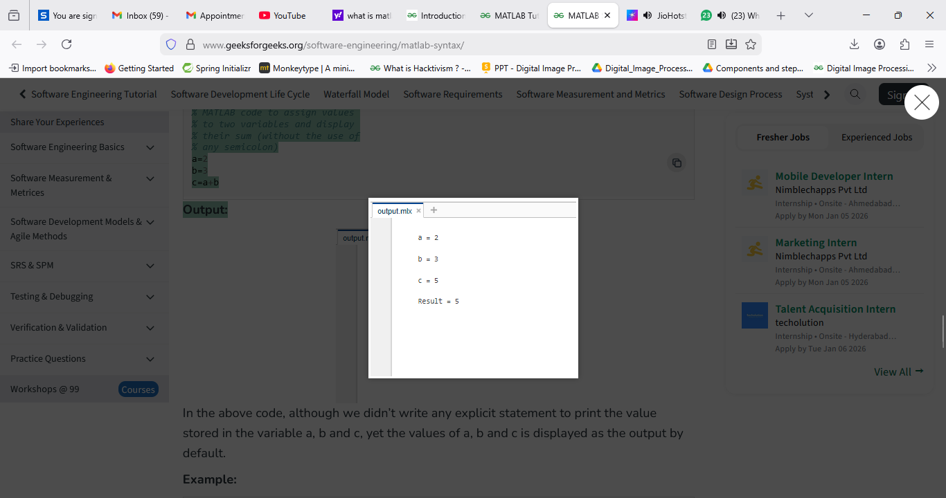
In the above code, although we didn’t write any explicit statement to print the value stored in the variable a, b and c, yet the values of a, b and c is displayed as the output by default.
Example:
% MATLAB code to assign values
% to two variables and display
% their sum (with the use of
% semicolon)
a = 2;
b = 3;
c = a+b
Output:
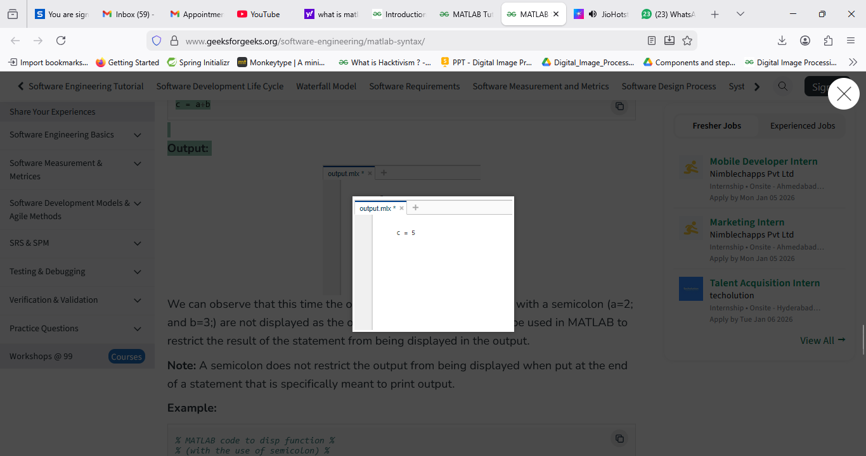
We can observe that this time the output of the statements ending with a semicolon (a=2; and b=3;) are not displayed as the output. Hence, a semicolon can be used in MATLAB to restrict the result of the statement from being displayed in the output.
Note: A semicolon does not restrict the output from being displayed when put at the end of a statement that is specifically meant to print output.
Example:
% MATLAB code to disp function %
% (with the use of semicolon) %

disp('Learning with Geeks for Geeks');
Output:
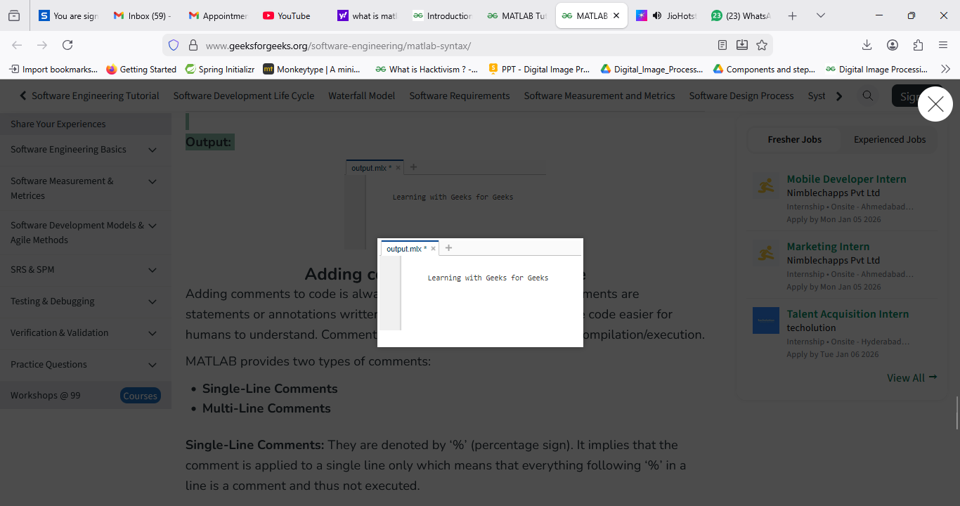

Adding comments in MATLAB code
Adding comments to code is always considered a good practice. Comments are statements or annotations written within the source code to make the code easier for humans to understand. Comments are simply ignored at the time of compilation/execution.

MATLAB provides two types of comments:
- Single-Line Comments
- Multi-Line Comments
Single-Line Comments: They are denoted by ‘%’ (percentage sign). It implies that the comment is applied to a single line only which means that everything following ‘%’ in a line is a comment and thus not executed.
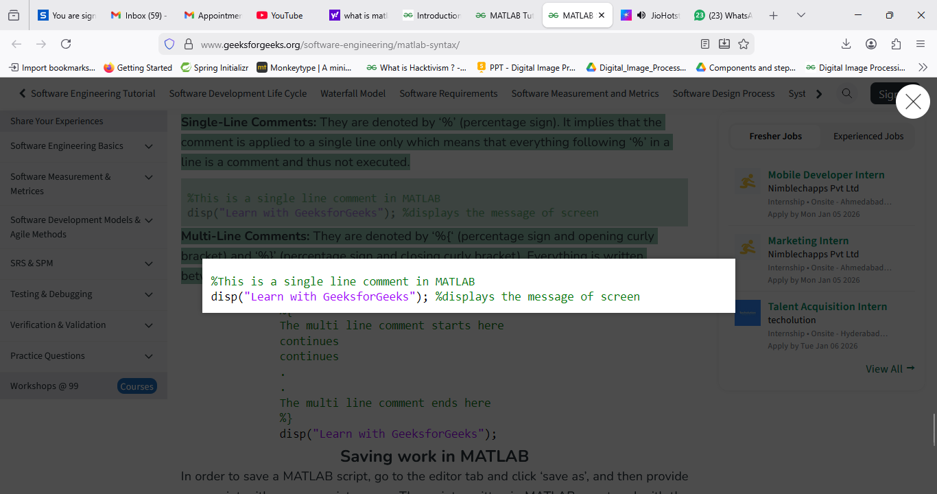
Multi-Line Comments: They are denoted by ‘%{‘ (percentage sign and opening curly bracket) and ‘%}’ (percentage sign and closing curly bracket). Everything is written between ‘%{‘ and ‘%}’ is a comment and thus not executed.
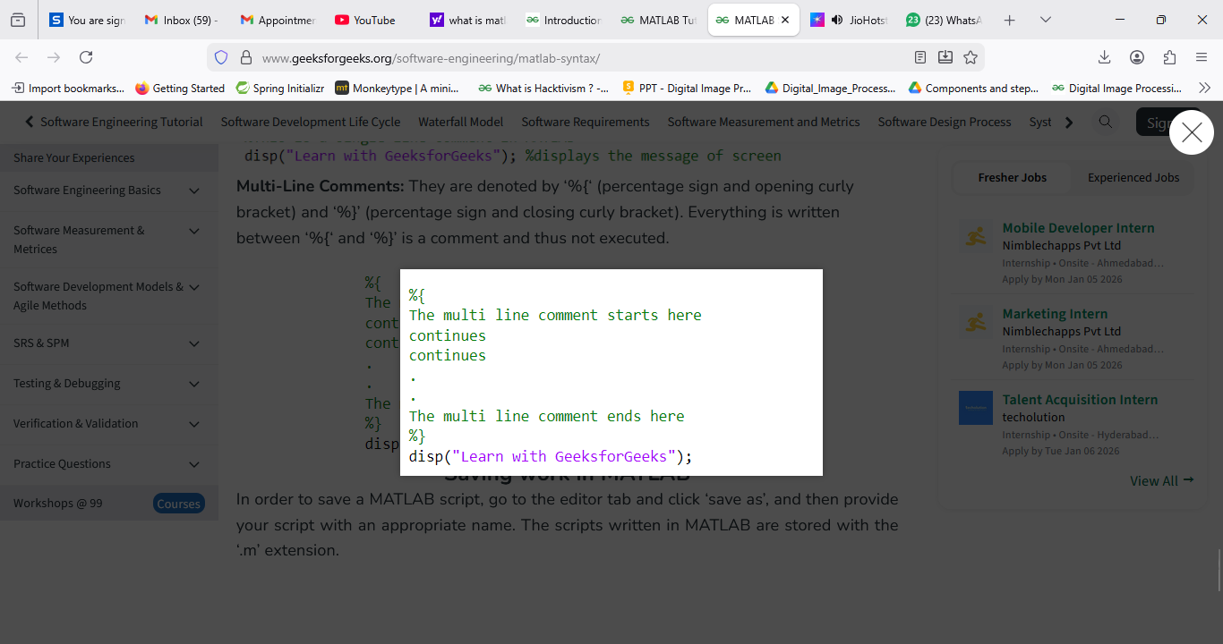

Saving work in MATLAB
In order to save a MATLAB script, go to the editor tab and click ‘save as’, and then provide your script with an appropriate name. The scripts written in MATLAB are stored with the ‘.m’ extension.

MATLAB - Data Types
MATLAB is a platform which provides millions of Engineers and Scientists to analyse data using programming and numerical computing algorithm and also help in creating models. Data types are particular types of data items defined by the values they can store in them, generally, in programming languages they are used.
Define data types in MATLAB
In MATLAB we do not require any type of declaration statement, when it gets any new variable name it creates the variable and allocates appropriate memory space to it but if the variable name already exists it will replace the original content with new content and allocate it to new storage space when required.
Syntax: variable name = a value (or an expression)
Example:
% MATLAB code for variable initialization
Geeks = 7;
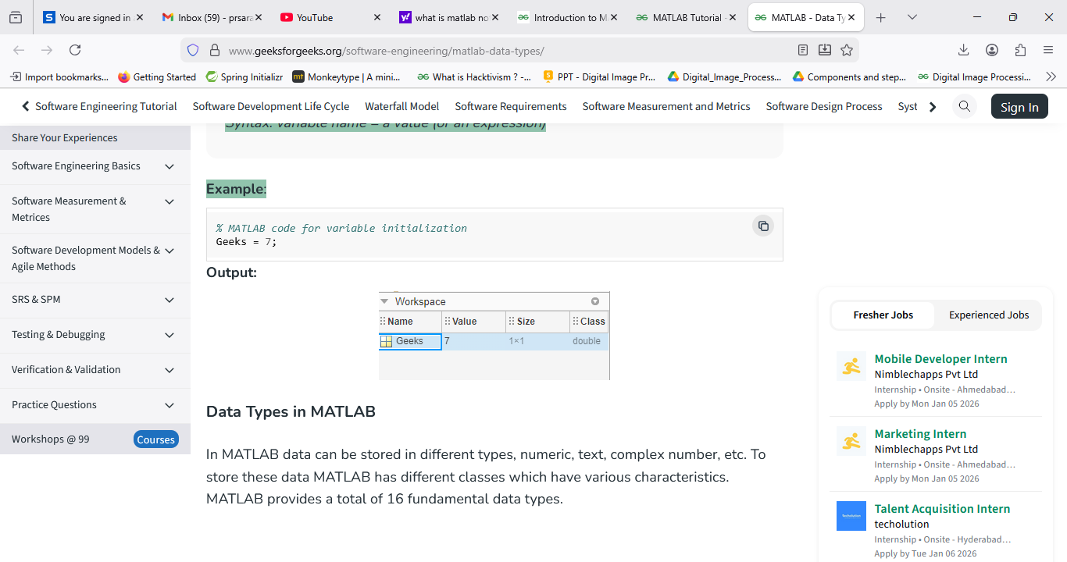

Data Types in MATLAB
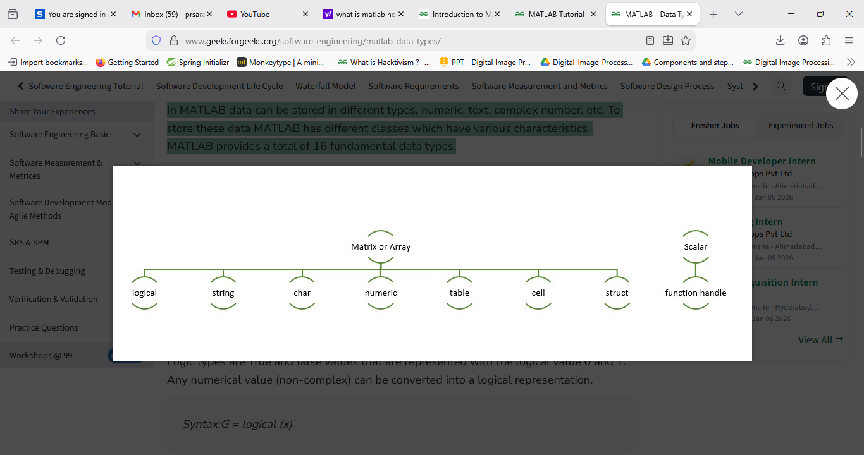
In MATLAB data can be stored in different types, numeric, text, complex number, etc. To store these data MATLAB has different classes which have various characteristics. MATLAB provides a total of 16 fundamental data types.

Logic Type
Logic types are True and false values that are represented with the logical value 0 and 1. Any numerical value (non-complex) can be converted into a logical representation.
Syntax:G = logical (x)
Example:
% MATLAB code for random matrix generation
rng default
A = randi(5,5) % It will generate random matrix of 5x5

B = A < 9 % The result is a logical matrix.
% Each value in B represents a logical 1 (true)
% or logical 0 (false) state to indicate whether
% the corresponding element of A fulfills the condition A < 9.
% For example, A(1,1) is 13, so B(1,1) is logical 0 (false).
% However, A(1,2) is 2, so B(1,2) is logical 1 (true).
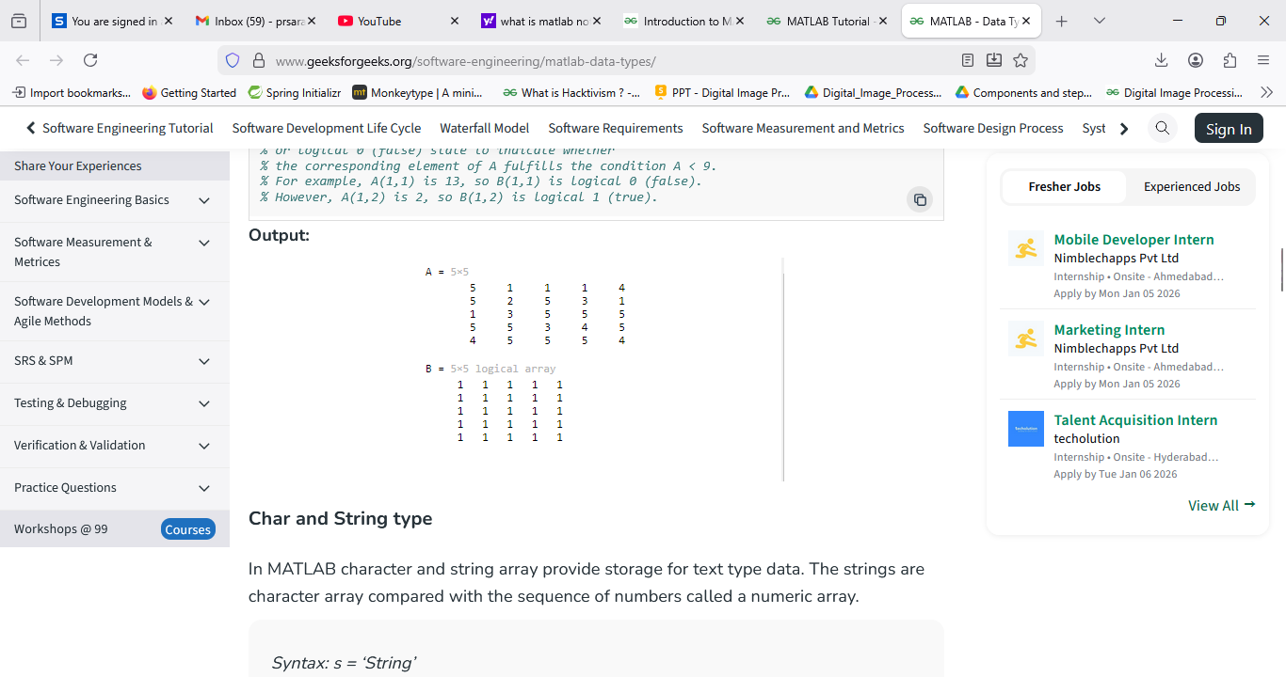

Char and String type
In MATLAB character and string array provide storage for text type data. The strings are character array compared with the sequence of numbers called a numeric array.
Syntax: s = ‘String’
Example:
% MATLAB code for showing String results
str = "Welcome to GeeksforGeeks, "
"Welcome!"" and lets start coding."
fprintf(str);
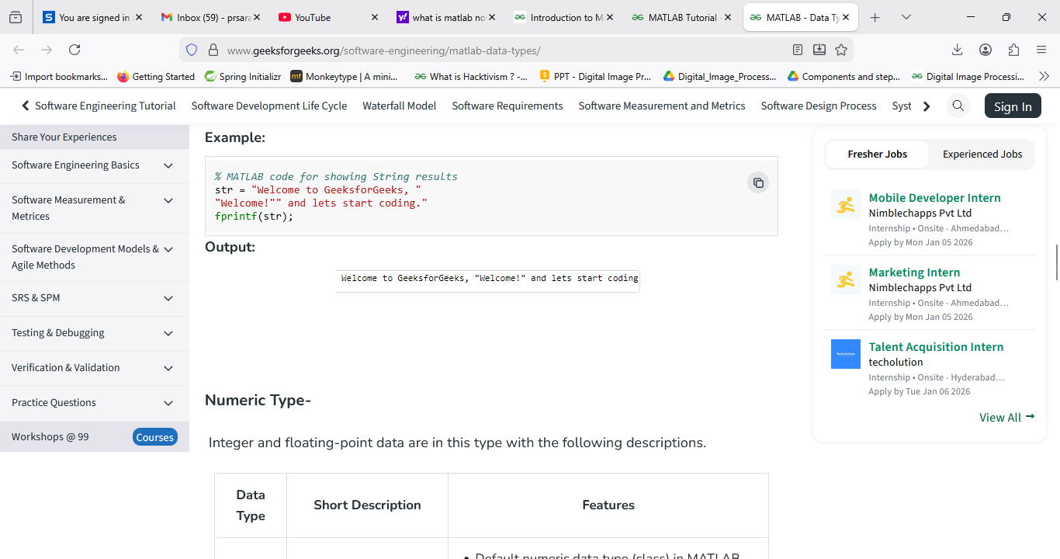

Numeric Type-
Integer and floating-point data are in this type with the following descriptions.
Data Type | Short Description | Features
double | Double-precision arrays | - Default numeric data type (class) in MATLAB  - Stored as 64-bit (8-byte) floating-point value  - Range:  Negative numbers = -1.79769 x 10308 to -2.22507 x 10-308  Positive numbers = 2.22507 x 10-308 to 1.79769 x 10308
single | Single-precision arrays | - Stored as 4-byte (32-bit) floating-point value  - Range-  Negative numbers = -1.79769 x 10308 to -2.22507 x 10-308  Positive numbers = 2.22507 x 10-308 to 1.79769 x 10308
int8 | 8-bit signed integer arrays | - Stored as 1-byte (8-bit) signed integers  - Range is -27 to 27-1
int16 | 16-bit signed integer arrays | - Stored as 2-byte (16-bit) signed integers  - Range -215 to 215 -1
int32 | 32-bit signed integer arrays | - Stored as 4-byte (32-bit) signed integers  - Range is -231 to 231-1
int64 | 64-bit signed integer arrays | - Stored as 8-byte (64-bit) signed integers  - Range is -263 to 263-1
uint8 | 8-bit unsigned integer arrays | - Stored as 1-byte (8-bit) unsigned integers  - Range is 0 to 28-1
unit16 | 16-bit unsigned integer arrays | - Stored as 2-byte (16-bit) unsigned integers  - Range is 0 to 216 -1
uint32 | 32-bit unsigned integer arrays | - Stored as 4-byte (32-bit) unsigned integers  - Range is 0 to 232-1
uint64 | 64-bit unsigned integer arrays | - Stored as 8-byte (64-bit) unsigned integers  - Range is 0 to 264-1

Example:
% MATLAB code for numeric type
str = 'Hello World';
int8(str)
Output:
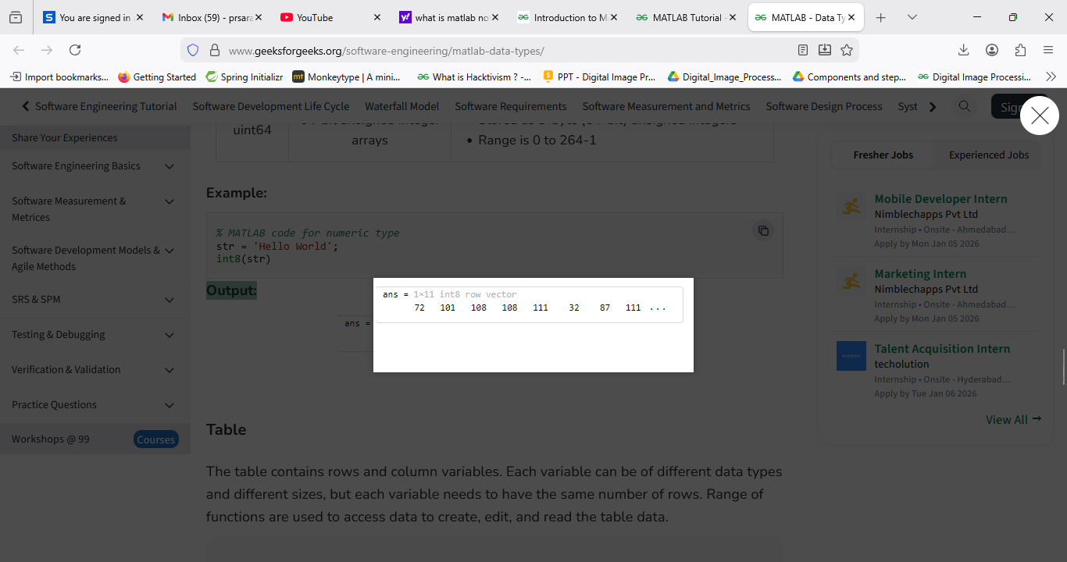

Table
The table contains rows and column variables. Each variable can be of different data types and different sizes, but each variable needs to have the same number of rows. Range of functions are used to access data to create, edit, and read the table data.
Syntax:T = table(ColumnName1,ColumnName2);
Example:
% MATLAB code for Table
T = table(Name,QuestionAttempted,CodingScore);
data = {'Atul Sisodiya',22,100};
Tnew = [Tnew;data];
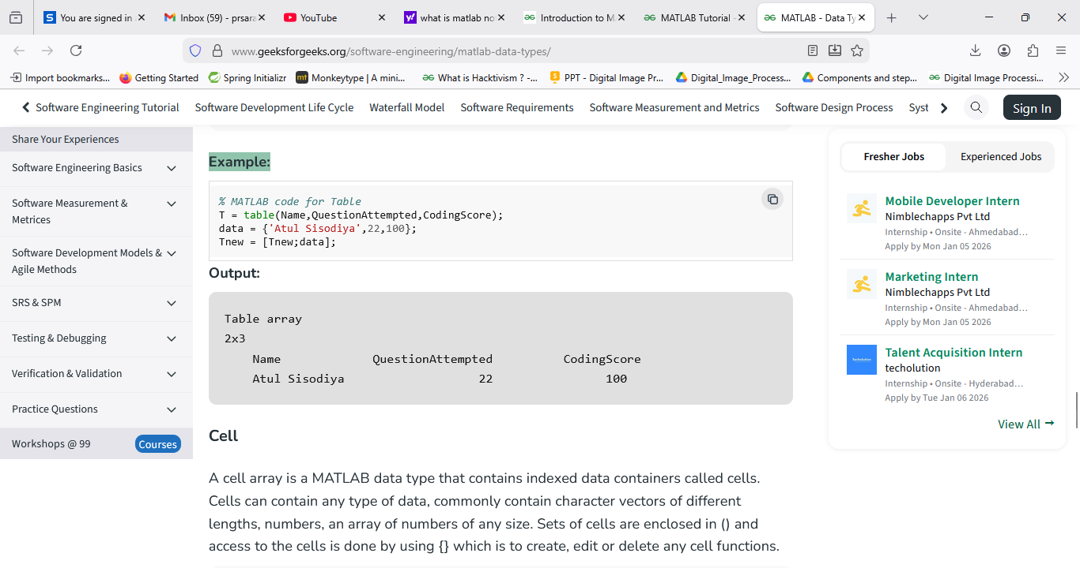

Cell
A cell array is a MATLAB data type that contains indexed data containers called cells. Cells can contain any type of data, commonly contain character vectors of different lengths, numbers, an array of numbers of any size. Sets of cells are enclosed in () and access to the cells is done by using {} which is to create, edit or delete any cell functions.
Syntax: c = { }
Example:
C = {1, 2, 3}
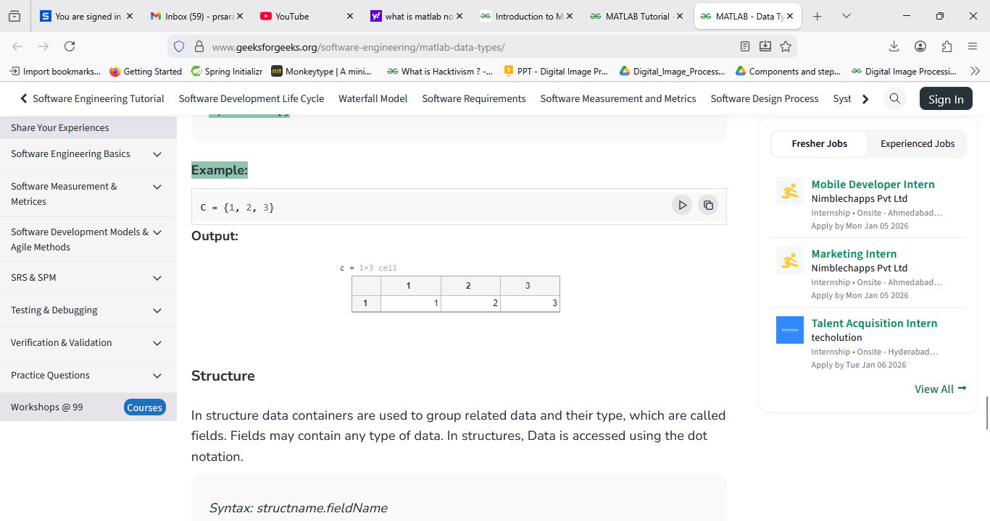

Structure
In structure data containers are used to group related data and their type, which are called fields. Fields may contain any type of data. In structures, Data is accessed using the dot notation.
Syntax: structname.fieldName
Example:
geek(1).name = ("Atul Sisodiya");
geek(1).coding = 100;
geek
Output:
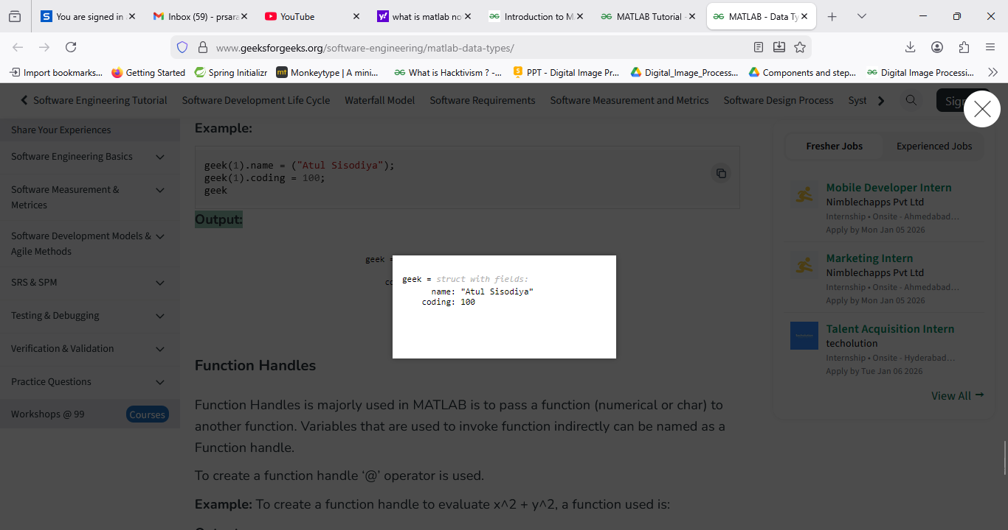

Function Handles
Function Handles is majorly used in MATLAB is to pass a function (numerical or char) to another function. Variables that are used to invoke function indirectly can be named as a Function handle.
To create a function handle ‘@’ operator is used.
Example: To create a function handle to evaluate x^2 + y^2, a function used is:
Output:
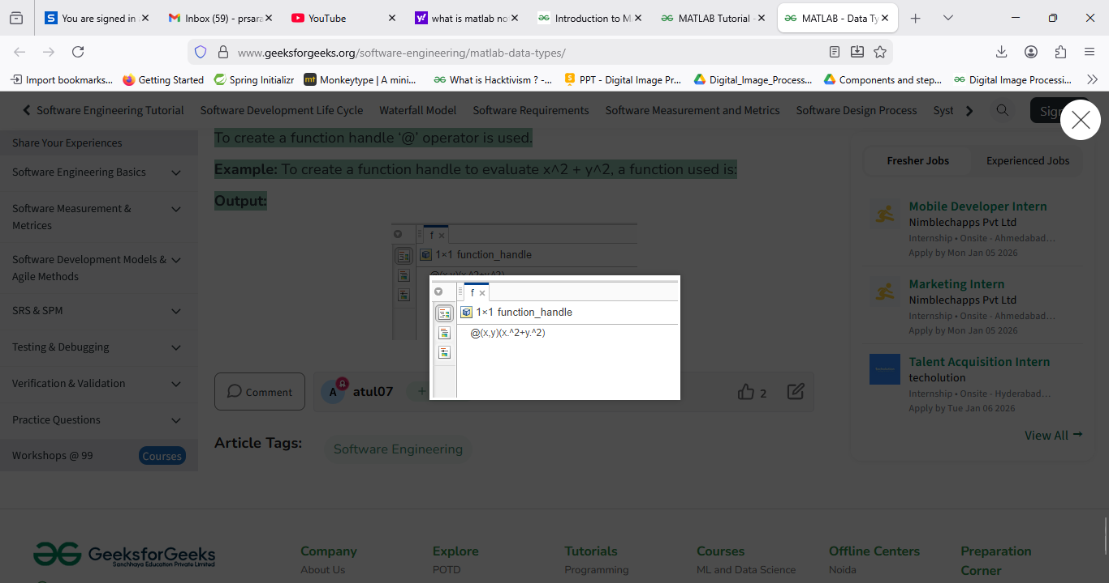

Matlab - Matrix
A Matrix is a two-dimensional array of elements. In MATLAB (short for Matrix Laboratory), the matrix is created by assigning the array elements that are delimited by spaces or commas and using semicolons to mark the end of each row.

Creating a Matrix in MATLAB
A matrix can be created by listing elements inside square brackets [ ].
- Elements in a row are separated by spaces or commas (,).
- Rows are separated by semicolons (;).

Syntax:
A = [elements; elements]
Example: Creating a Matrix
% Creating numeric and string matrices
x = [1 2 3; 4 5 6; 7 8 9];
y = ['Geek'; 'Geek'];
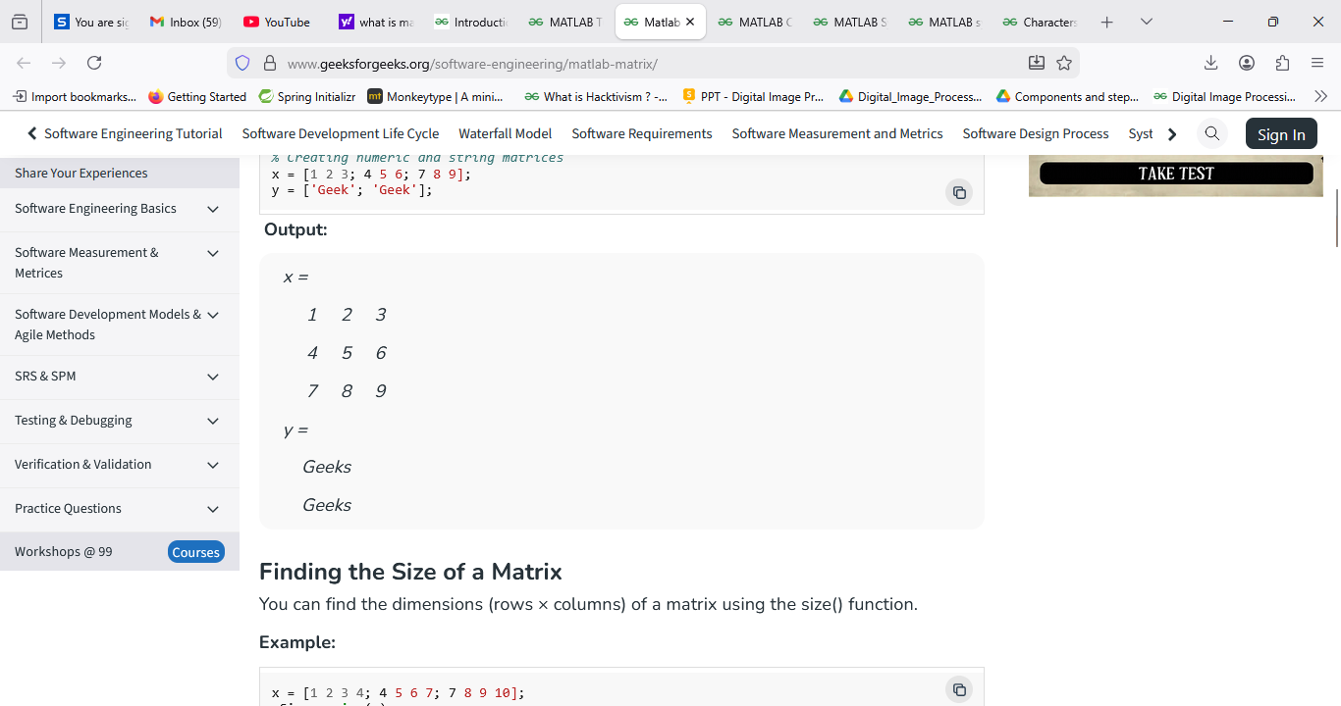

Finding the Size of a Matrix
You can find the dimensions (rows × columns) of a matrix using the size() function.
Example:
x = [1 2 3 4; 4 5 6 7; 7 8 9 10];
xSize = size(x)

y = ['Geeks'; 'Geeks'];
ySize = size(y)
Output:
xSize =
3 4
ySize =
2 5

Accessing Matrix Elements
To access specific elements, use the syntax:
matrix(row, column)
Example 1: Access a Single Element
x = [1 2 3 4; 4 5 6 7; 7 8 9 10];
x(3,2) % Access element in 3rd row, 2nd column
Output:
ans =
8
Example 2: Accessing Multiple Elements
To access multiple elements:
- x(:, :) -> all rows and columns
- x(1:2, :) -> first two rows
- x(:, 2:end) -> all rows, columns from 2 to end
x = [1 2 3 4; 4 5 6 7; 7 8 9 10];

x(:, :)
x(1:2, :)
x(:, 2:end)
x(1:2, 2:3) % Elements from 2nd to 3rd column in first two rows
Output:
ans =
1 2 3 4
4 5 6 7
7 8 9 10
ans =
1 2 3 4
4 5 6 7
ans =
2 3 4
5 6 7
8 9 10
ans =
2 3
5 6

Adding Elements or Dimensions
You can add rows or columns to a matrix using concatenation ([]) or the cat() function.

Syntax:
cat(dimension, A, B, ...)
- dimension = 1 -> adds rows
- dimension = 2 -> adds columns
Example 1: Using Brackets
x = [1 2 3 4; 4 5 6 7];
y = [7 8 9 10; 11 12 13 14];

a = [x; y]; % Add rows
b = [x; 11 12 13 14]; % Add a new row
x(:,5) = [15; 16]; % Add a column
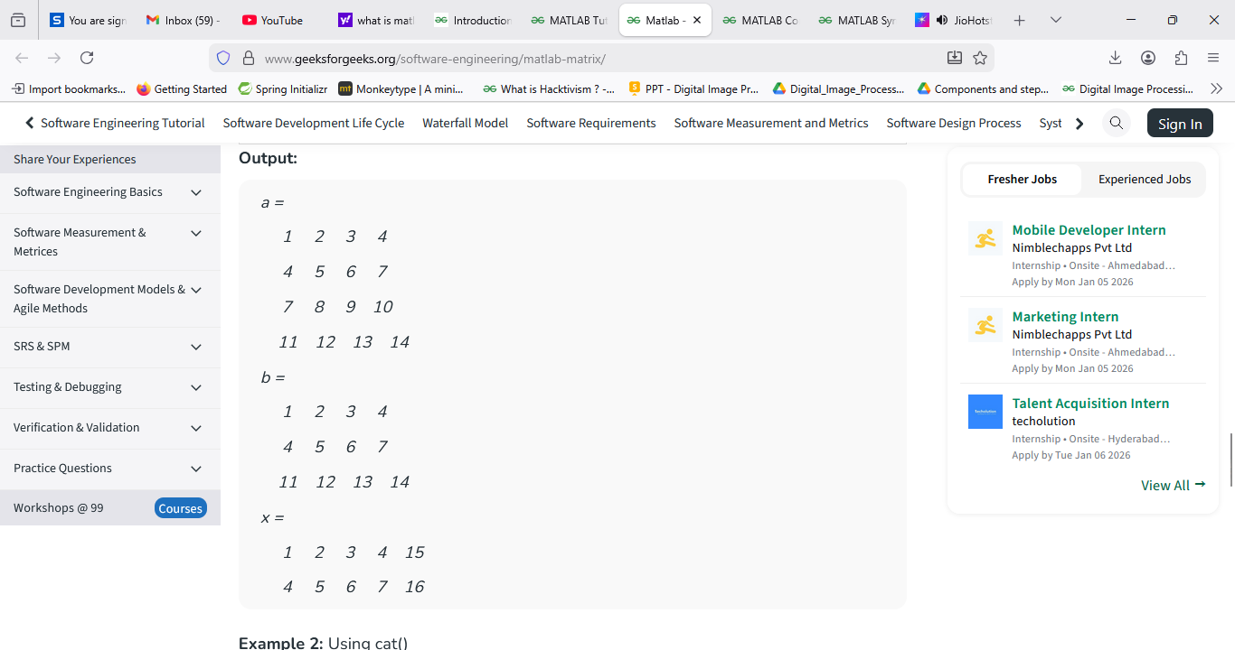
Example 2: Using cat()
x = [1 2 3 4; 4 5 6 7];
y = [1 2 3 4; 4 5 6 7];

a = cat(1, x, y); % Add rows
b = cat(2, x, y); % Add columns
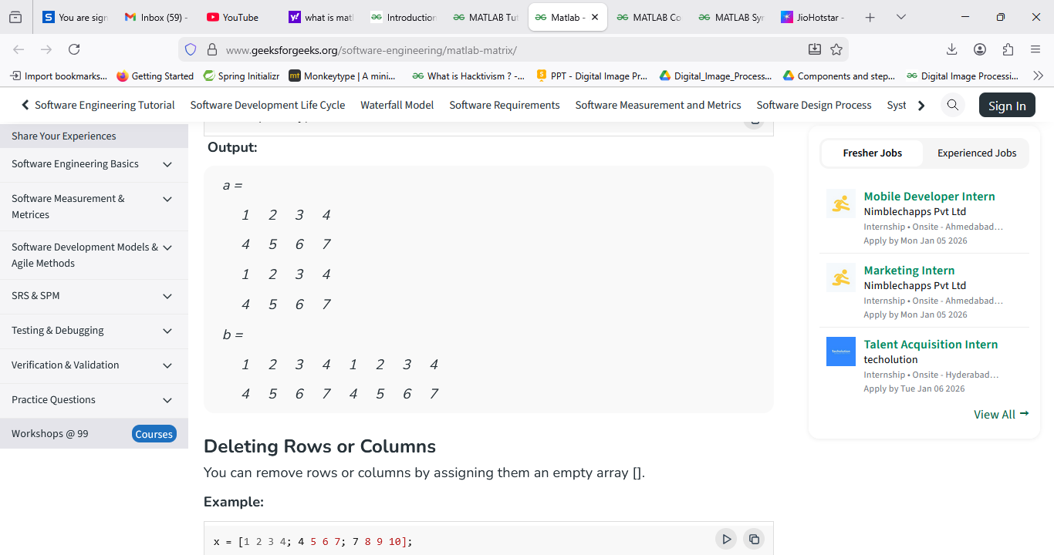

Deleting Rows or Columns
You can remove rows or columns by assigning them an empty array [].
Example:
x = [1 2 3 4; 4 5 6 7; 7 8 9 10];

x(3,:) = []; % Delete 3rd row
x(:,3) = []; % Delete 3rd column

Key Points
- MATLAB indices start at 1 (not 0).
- For most operations, matrices must have the same dimensions.
- Use a semicolon (;) at the end of a statement to suppress intermediate outputs.
- In MATLAB, a string is treated as a character array.
- length() gives the total number of elements in a vector, while size() returns matrix dimensions.

Creating Function in Files in MATLAB
MATLAB is a high-performance language that is used for matrix manipulation, performing technical computations, graph plottings, etc. It stands for Matrix Laboratory.

Functions:
The function is a set of statements or commands, which take input/s as parameters and return output. We write functions to use it again and again in the program i.e. it makes a block of code reusable. It makes it easier to find errors and also reduces code redundancy.

Types of Function:
- Library Functions: In MATLAB Software, there are some inbuilt functions, which take input as arguments and return output. E.g. log(x), sqrt(x), line space(a,b,n), etc.
- User-Defined Functions: In MATLAB, we also create functions by writing Matlab commands in files that take input/s as argument/s and then return the output. Also, save the function file using the name of the function itself.

Steps to Create a Function File in MATLAB:
- Step 1: Create a file and write commands using the function keyword.
- Step 2: Save the function file with the same name as the function. Here I have saved the file with the name solve.m.
- Step 3: Use the function in Command Video by providing suitable argument/s.
Now we see creating a function and saving it in MATLAB.
Example 1:
% function to calculate sin(x)+cos(x) where x is in radians
% Here solve is the name of the function which
% will return x and takes an argument a
function x = solve(a)
x = sin(a) + cos(a);
Using the function to be called in Command Window.
Example 2:
input = 1.5708;

% display the function's output
disp(solve(input));
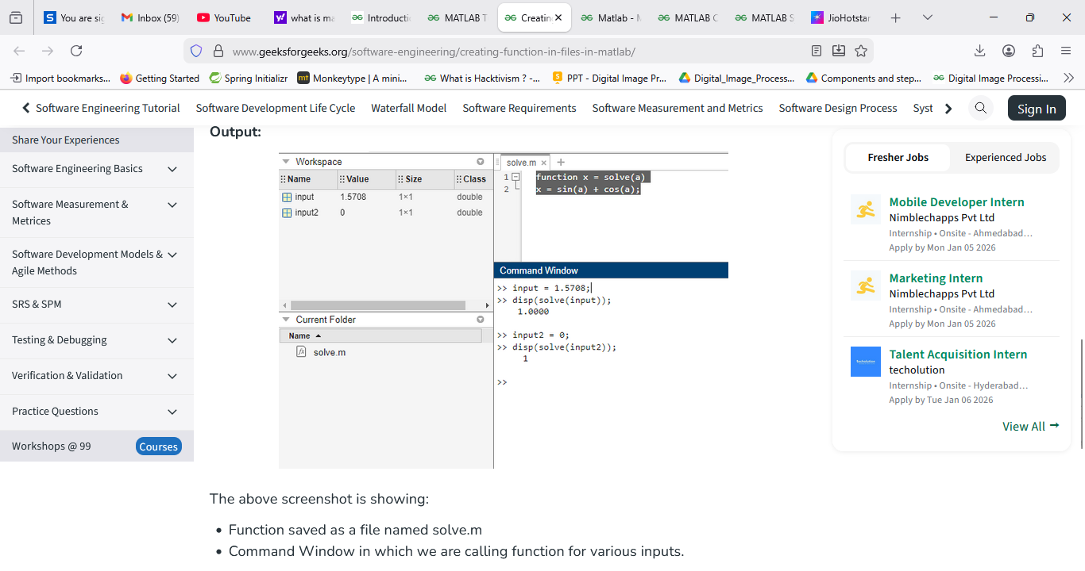
The above screenshot is showing:
- Function saved as a file named solve.m
- Command Window in which we are calling function for various inputs.

Image Processing in MATLAB

Fundamental Operations
1. Reading Images
Images are read into the MATLAB Environment using imread() function which takes filename with applicable extension as the argument
For Example:
>> I=imread('nature.jpg');
This will read JPEG image 'nature' into the image array.
Note: The semicolon(;) at the end of command line is used to suppress the output in MATLAB.If ';' is not used at the end, it will show the output of the specified operation.
2.Displaying Images
imshow() function is used to display images in MATLAB. The basic syntax of imshow() is
imshow(f, G);
Here f is image matrix and G is number of intensity level used to display the image. The second Argument in the above syntax is optional. If G is omitted its value defaults to 256 levels.
When we use the syntax
imshow(f, [Low, High]);
It displays all value less than or equal to 'Low' as black and all values greater than or equal to 'High' as white. The values between 'Low' and 'High' are displayed as the intermediate intensity value using the default number of levels.
Examples:
Showing Grayscale Images
>> imshow(f);
This will display the grayscale image f.
Also, we can write
>> imshow(f, [90, 180]);
It will display all value less than or equal to 90 as black and all values greater than or equal to 180 as white. The values between 90 and 180 are displayed as the intermediate intensity value using the default number of levels.
Showing Binary images
>> imshow(BW);
It displays the binary image BW. It displays pixels with the value 0 (zero) as black and pixels with the value 1 as white.
Showing RGB images
>> imshow(f);
It displays the RGB image f.
3. Writing images to disk
Images are written to disk using imwrite() function. The basic syntax of imwrite() is
imwrite(f, 'filename');
Here f is our image and filename is the name of file including a recognized file format extension. Alternatively, we can also specify desired format explicitly with a third argument.
For example
>> imwrite(f, 'nature.jpg');
Alternatively, we can write it as,
>> imwrite(f, 'nature', 'jpg');
The above commands write image f to a filename nature with extension jpg.
Note: The imwrite() function have some optional parameters too, depending upon file format.
For example:
>> imwrite(f, 'filename', 'quality', q);
The above syntax is applicable for only JPEG images. Here q is an integer and can take value between 0 to 100. Lower the value of q higher the degradation due to JPEG compression.
Some Other Important functions
i.) imfinfo
It displays the details of an image file
Example:
>> imfinfo nature.jpg;
Output:
Filename: 'nature.jpg'
FileModDate: '23-Jun-2016 09:57:04'
FileSize: 238290
Format: 'jpg'
FormatVersion: ''
Width: 1920
Height: 1200
BitDepth: 24
ColorType: 'truecolor'
FormatSignature: ''
NumberOfSamples: 3
CodingMethod: 'Huffman'
CodingProcess: 'Sequential'
Comment: {'CREATOR: gd-jpeg v1.0 (using IJG JPEG v80), quality = 92?'}
ii.) size()
size() function take image matrix as an argument and give the row and column dimension of an image f. This function is used to determine the size of an image automatically.
Example :
>> size(f)
Output :
ans =
1920 1200
Here 1920 is the number of rows and 1200 is the number of columns in image f.
Note: As we know RGB images are represented using 3-D matrix in MATLAB. So, if f is a RGB image the above function will produce output as
ans =
1920 1200 3
iii.) whos f
This function will show additional detail about image matrix f.
Example :
whos f
Output :
Name Size Bytes Class Attributes
f 300x400x3 360000 uint8

MATLAB Commands
MATLAB is an interactive multi-programming language and numeric computing environment developed by MathWorks. MATLAB provides the Commands that will be used when the user wants to interact with any application using the command line interface.
Following are the lists of commands used in MATLAB.

Commands for Managing a Session
Command | Use
clc | Clears command window
clear | Removes the variables from memory
global | Declares variables globally
exist | Checks for the existence of a particular file or memory
help | Searches for a help topic
quit | Stops MATLAB
who | Lists current variables in use
lookfor | Searches help entries for a keyboard
Example 1
% MATLAB Code to illustrate
% global
function setGlobalx(val)
global x
Output:
x = val;
Example 2
% MATLAB Code to illustrate who
x = 2
who
Output:
Variables in the current scope: x
Example 3
% MATLAB Code to illustrate
% clear
clear
type x
Output:
error: type 'x' is undefined

Commands for Working with the System
Command | Use
cd | Changes current directory
date | Displays current date
delete | Deletes a file
dir | Lists all the files in a directory
path | Displays search path
pwd | Displays current directory
type | Displays content of a file
wklread | Reads.wk1 spreadsheet file
save | Saves workplace variables in a file
Example 1
% MATLAB Code to illustrate
% pwd
pwd
Output:
ans = /home/oo
Example 2
% MATLAB Code to illustrate
% date
c = date
Output:
c= '18-jun-2021'

Input and Output Commands
Command | Use
disp | Displays content of an array or a string
fscanf | Reads formatted data from a file
format | Controls screen-display format
fprintf | Performs formatted writes to file or screen
input | Displays the prompt and waits for input
; | Suppresses screen printing
Example 1
% MATLAB Code to illustrate
% disp

A = [15 150];
S = 'Hello World.';
disp(A)
disp(S)
Output:
15 150

Hello World.
Example 2
% MATLAB Code to illustrate
%input
age = input('how old are you: ');
% At this point, the variable: age, will contain
% whatever value the user types
Output:
20

Vector, Matrix, and Array Commands
Command | Use
cat | Concatenates the array
find | Finds the indices of nonzero elements
max | Returns the largest element
min | Returns the smallest element
prod | Product of each column
sort | Sorts each column
rank | Computes rank of a matrix
eye | Creates an identity matrix
inv | Computes the inverse of a matrix
Example 1
% MATLAB Code to illustrate
%cat
array1 = [1,2,3]
array2 = [4,5,6]
cat(1,array1,array2)
Output:
ans =

1 2 3
4 5 6
Example 2
% MATLAB Code to illustrate
%max
max(array1)
Output:
ans = 3
Example 3
%MATLAB Code to illustrate
%min
min(array2)
Output:
ans = 4
%MATLAB Code to illustrate
%eye
eye(2,2)
Output:
ans =
Diagonal Matrix
1 0
0 1
Plotting Commands:
Commands | Use
axis | Sets axis limit
grid | Displays grid lines
plot | Generates xy plot
title | Puts title at top of the plot
close | Closes current plot
bar | Creates bar chart
print | Prints the plot / saves the plot
figure | Opens a new figure window
Close all | Closes all plots
Example1:
% MATLAB Code to illustrate
%plot
x = linspace(0,20)
y = cos(x)
plot(x,y)
Output:
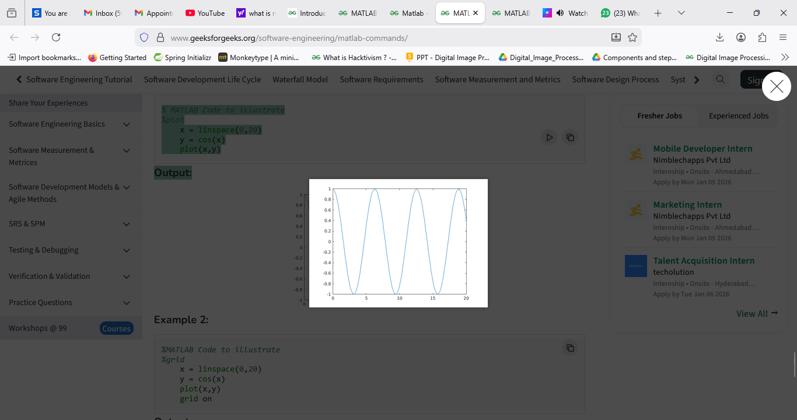
Example 2:
%MATLAB Code to illustrate
%grid
x = linspace(0,20)
y = cos(x)
plot(x,y)
grid on
Output:
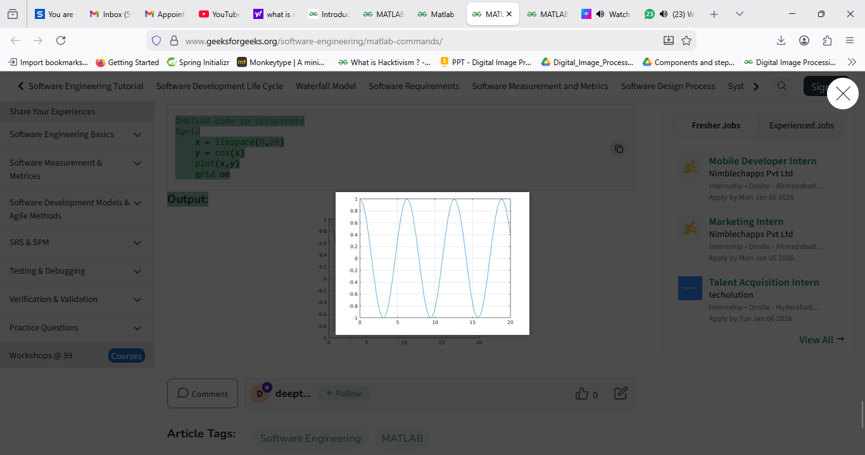

MATLAB Image Processing Toolbox
The MATLAB Image Processing Toolbox is a comprehensive suite of algorithms and functions designed for image analysis, enhancement, and manipulation. It extends MATLAB's capabilities, enabling users to perform advanced image processing tasks efficiently.

Key Features
- Image analysis and enhancement
- Geometric transformations
- Image segmentation
- Feature detection and extraction
- Morphological operations
To begin using the Image Processing Toolbox, ensure it's installed with your MATLAB distribution. You can verify its availability by running:
ver('image')

Basic Image Operations
Let's explore some fundamental operations using the toolbox:

1. Reading and Displaying Images
% Read an image
img = imread('sample_image.jpg');

% Display the image
imshow(img);

2. Image Enhancement
Enhance image contrast using histogram equalization:
enhanced_img = histeq(img);
imshow(enhanced_img);

Advanced Techniques
The Image Processing Toolbox offers sophisticated algorithms for complex tasks:

1. Edge Detection
edges = edge(rgb2gray(img), 'Canny');
imshow(edges);

2. Image Segmentation
Segment an image using the K-means clustering algorithm:
[L, Centers] = imsegkmeans(img, 3);
B = labeloverlay(img, L);
imshow(B)

Integration with Other MATLAB Features
The Image Processing Toolbox seamlessly integrates with other MATLAB capabilities:
- Signal Processing Toolbox for advanced filtering techniques
- Statistics Toolbox for statistical analysis of image data
- Parallel Computing for processing large image datasets

